Week2 Learning Journal

Student Name: Qingbo Tan

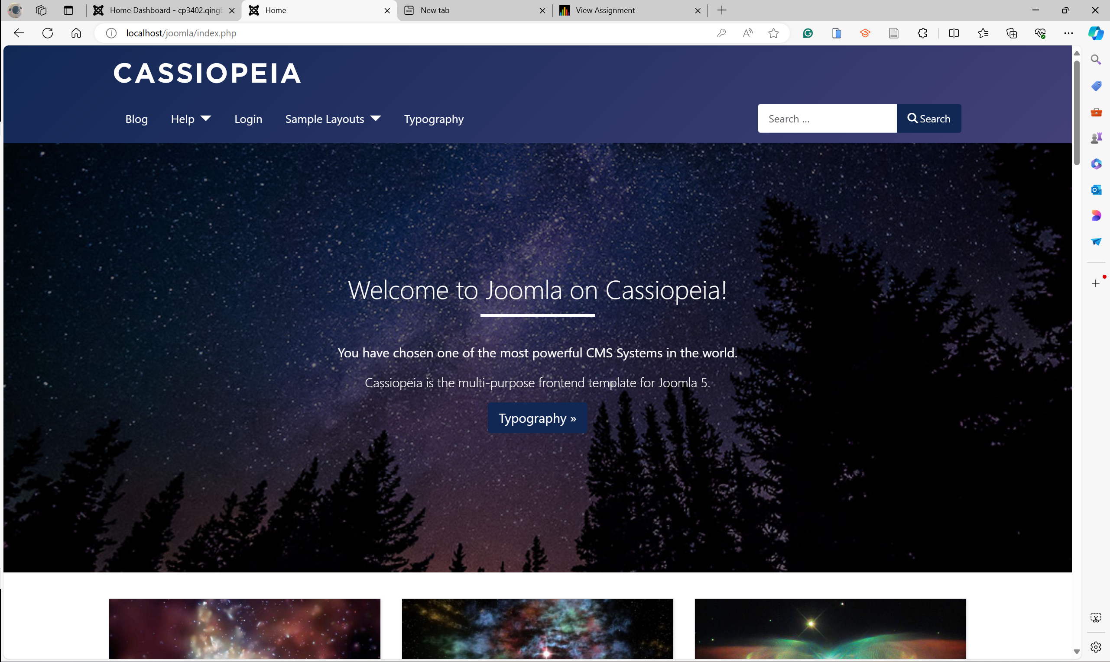

While learning and using Joomla, I encountered several challenges. One issue was needing to connect to MySQL on my personal computer to download the complete Joomla component, which caused some operational problems. Additionally, while using the web editor to edit my web pages, I faced further difficulties. For instance, Joomla provides a template called CASSIOPEIA, but many elements, including pictures, are not editable. Despite trying numerous solutions, I was unable to make the necessary modifications.

Estimated Hours

this week I use at least 10h in my work, including to search how to solve my problem and learn how to use Joomla.

Content Insights

Joomla is a powerful component that I've used this week. As an open-source platform, Joomla! allows anyone to view, modify, and distribute its source code, fostering a large developer community that continually enhances the platform. Joomla! offers a rich set of extensions and templates, making it highly adaptable to various website needs. Numerous third-party developers contribute plugins, modules, and themes to expand its functionality. Additionally, Joomla! boasts excellent scalability, allowing it to be extended with plugins, modules, and components to meet the specific requirements of different types of websites.